ARIZA DOOR WINDOW ALARM

Features and Capabilities:

- Door Status Detection.
- Notification.
- When Door is open Buzzer sounds for 2 sec.

DAIS:
Device:
{
"_id": "10ca2000",
"deviceTypeId": "ezlopi",
"parentDeviceId": "",
"category": "security_sensor",
"subcategory": "door",
"gatewayId": "457a5069",
"batteryPowered": false,
"name": "Ariza Door Window Alarm",
"type": "sensor",
"reachable": true,
"persistent": false,
"serviceNotification": false,
"armed": false,
"roomId": "",
"security": "no",
"ready": true,
"status": "idle",
"parentRoom": true,
"protectConfig": "default"
}

Item:
{
"_id": "20ca2000",
"deviceId": "10ca2000",
"hasGetter": true,
"hasSetter": false,
"name": "dw_state",
"show": true,
"valueType": "token",
"enum": [
"dw_is_closed",
"dw_is_opened",
"unknown"
],
"valueFormatted": "dw_is_closed",
"value": "dw_is_closed",
"status": "idle"
},

{
"_id": "20ca2001",
"deviceId": "10ca2000",
"hasGetter": true,
"hasSetter": false,
"name": "battery",
"show": true,
"valueType": "int",
"scale": "percent",
"value": 97,
"valueFormatted": "97",
"status": "idle"
},
{
"_id": "20ca2002",
"deviceId": "10ca2000",
"hasGetter": true,
"hasSetter": false,
"name": "security_threat",
"show": true,
"valueType": "bool",
"value": false,
"valueFormatted": "false",
"status": "idle"
}

Pictures:
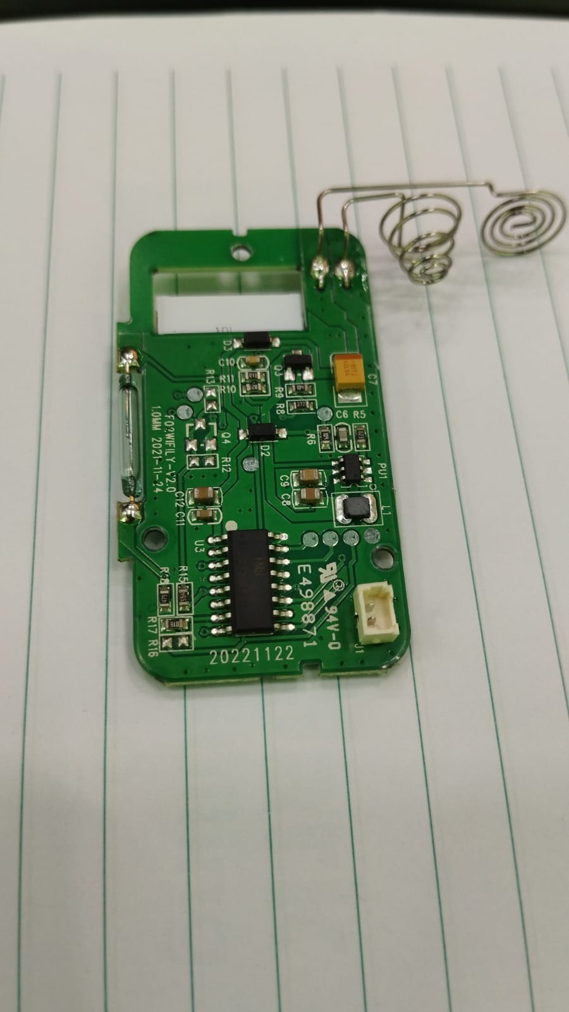
PCB Front Side
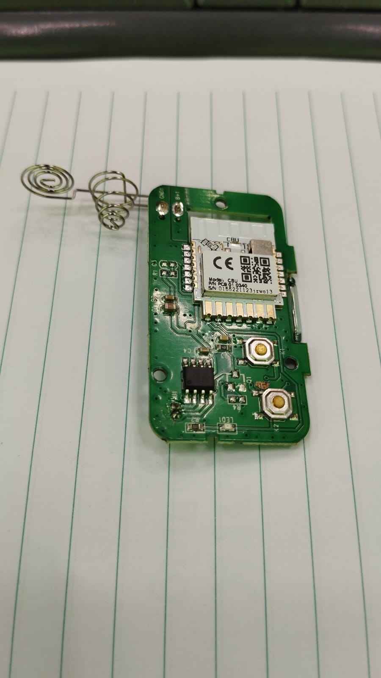
PCB Back Side
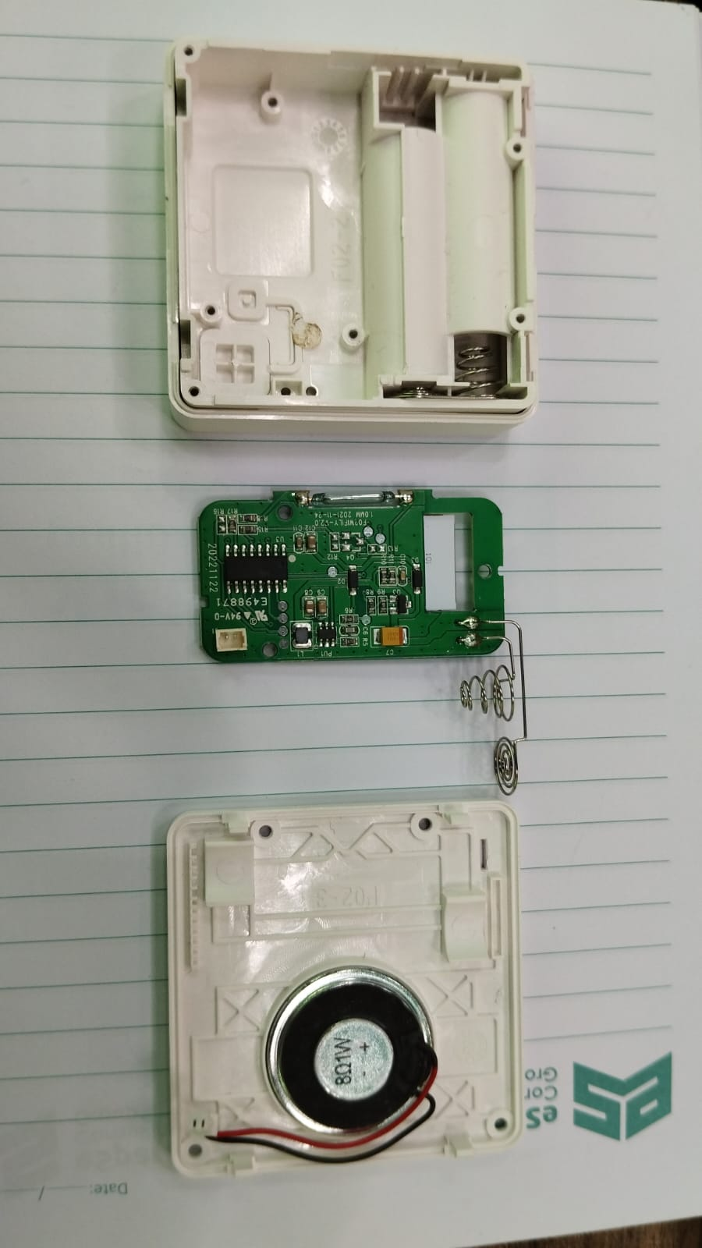
Device From Inside

